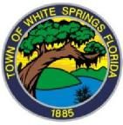

TOWN OF WHITE SPRINGS

“On the Banks of the Suwannee River”

**WORKSHOP**

**2025 ELECTION**

**CANDIDATE PACKET**

MARCH 17, 2025

5:30PM

TOWN HALL

386-2310

Audre’ J. Ruise

Town Clerk

Leslie Jean-Bart

Town Attorney